**Smart Water Fountain**

**Definition :**

Today, more people around the world have pets than ever before. According to American Pet Products Association’s survey in 2020, 67% of U.S. households own a pet which is about 84.9 million homes. This proportion has been increased by 20% in thirty years [1]. Breakdown of the pet types, cats and dogs are the most popular animals, they contribute to about 80% of all pets. Same trend happens all over the world. On average, one in three households own a dog globally and about a quarter of households worldwide own a cat [2]. Both cats and dogs prefer flowing water. A source of fresh clean running water can encourage pets to drink. Drinking a certain amount of water daily plays an important role in long-term health for pets, especially cats. As a result, a water fountain is essential to most households having cats or dogs as pets. However, we can not ensure the water quality when we are away from home for several days. It can happen when pets have finished all remaining water in the water fountain, or water has been polluted somehow by the pet. These can cause the pet to be unwilling to drink water from the fountain. Our goal is to design a smart water fountain that can monitor the water quality and automatically replace water when polluted(not healthy) or running out. We will use sensors to measure the water quality. Common water quality measurement factors include temperature, Ph-value, conductance, turbidity and hardness [3]. Considering the pollution at home can only affect limited factors, we choose temperature, Ph-value and conductance to be the three properties used for calculating water quality in our water fountain. These data will be collected, calculated, and reflected to the user in terms of “Good”, “Average” and “Bad”. The water fountain is also designed to self-filter the water every time when water is pumped through the submersible water pump.

Background:

There have been quite a lot of water fountain products on the market[4], while most of them have only filtration as an extra function besides providing running water. [5] The size of the water fountain limits the capacity of the water source that most water fountains cannot store enough water for multiple pets to drink in several days. Our water fountain can be connected to an extra water source that provides enough water for long-term usage. The link is adaptable to universal water bottles for convenience. The sufficient water source as well as automatic replacing and refilling function enable pet owners to leave home for several days without worrying about water supply for pets.

**Design :**

The block diagram below is a general design of our solution. We divide our design into four modules, including Power Supply, Control Unit, External Control, and Mechanical Unit. Details of each unit is presented in the diagram and described in the next section.

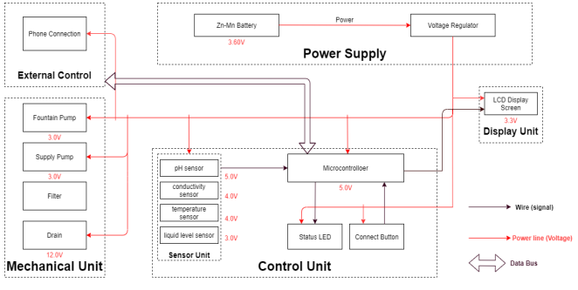

Figure 1 : Block Diagram of Smart Water Fountain

Physical Design:

A pictorial representation of your project that puts your solution in context. Not necessarily restricted to your design. Include other external systems relevant to your project (e.g. if your solution connects to a phone via Bluetooth, draw a dotted line between your device and the phone). Note that this is not a block diagram and should explain how the solution is used, not a breakdown of inner components.

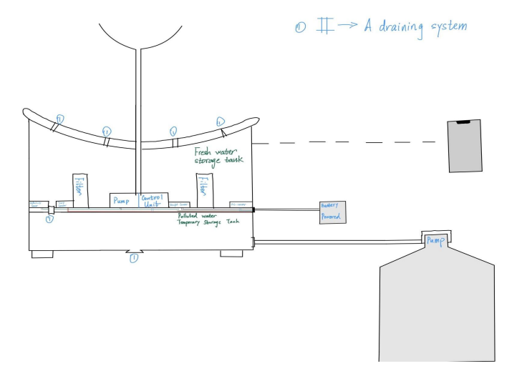

Figure 1.2 : Smart Fountain Physical Diagram

**PRESENTED BY:**

**ASWIN**

**DIVYANANTHAN**

**HARISH**

**SANJAY KUMAR**